I did not get the titles. I did get the data and the extra credit with the differences

2018

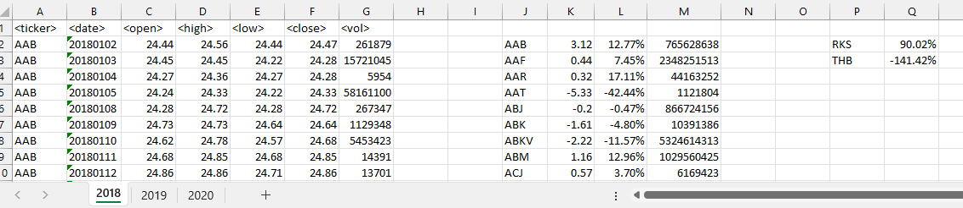

2019

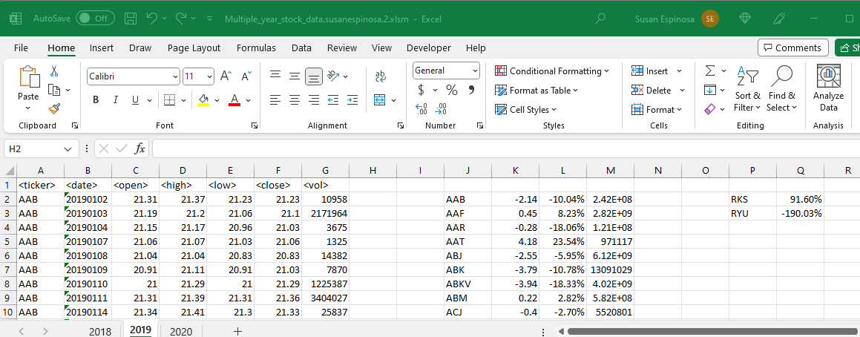

2020

